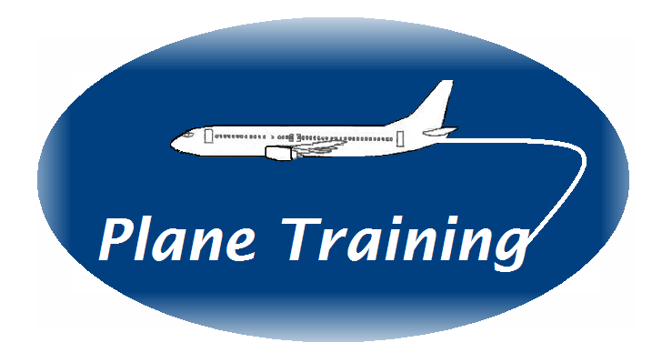

INSTRUCTIONAL TECHNIQUES COURSE

This four-day course is intended either for new instructors or those instructors wishing to refresh their current skills. It is intended for those who train within a classroom (ground trainers) or aircraft environment (line trainers), whether it be on an individual or group basis. The aim of this course is ‘To be able to design and deliver training sessions with competence, clarity and confidence. To be able to assess work performance and deliver effective feedback.’ During the course, each delegate will prepare and deliver three presentations, which will be recorded on video and then discussed.

DAY ONE – TEACHING AND LEARNING PROCESSES
Introduction to Course
Effective Training
Exercise to identify what constitutes effective training and learning
Contracting

Exploring the benefits of setting up a contract with trainees and fellow trainers
Learning Styles

Different personalities and how they affect the learning process
The Learning Process

How people learn and retain information
Practise Session Number One – Training without Preparation
Each delegate to deliver a 2-minute presentation on a given topic
Discussion and Feedback from practise session
Questioning Techniques
How to ask effective questions

DAY TWO – TRAINING PREPARATION
Review of Day One
The Training Cycle
Using the training cycle to develop training sessions
Aims and Objectives

Establishing training objectives and learning outcomes
Session Planning and Design

Preparing lesson plans and instructor guides
Presentation skills and delivering the course/Developing Trainers confidence
Training and Visual aids
PowerPoint, flip charts etc

DAY THREE – TRAINING DELIVERY AND FEEDBACK
Review
Practise Session Number Two
Each delegate to prepare and deliver a 10-minute training or briefing session on a work related subject. This to be recorded
Discussion and Feedback from training session
Training Styles

Lecture, discussion etc
Instruction and Facilitation
Feedback

How to give motivational and developmental feedback

DAY FOUR – GROUP DYNAMICS, PRACTISE SESSION, REPORT WRITING
Review
Behaviour and its impact on the training process
Managing Difficult Behaviours

How groups form and function together and dealing with individuals within the group
Presentation Session Number Three

Each delegate to prepare and deliver a 15-minute skills based training session Assessment and discussion of practise sessions with each delegate
Report writing
Course Review

COURSE OBJECTIVES

By the end of this 4-day course, you will be able to:

- Know what effective training is and able to identify good and poor training characteristics
- Describe effective training through competency based assessment
- Know the different adult learning styles and what your prevalent style is
- Identify how the different styles help and hinder learning
- Describe how the trainers style can affect the learning process
- Know how adults learn and retain information and develop skills
- Know and use the 5 stages of the training cycle
- Use the training cycle for course preparation, course delivery and evaluation
- Set clear learning outcomes for knowledge, skill and attitude based training sessions
- Structure lesson plans for both theoretical and practical training sessions
- Able to use visual aids competently
- Conduct effective theoretical and practical training sessions within a set time frame
- Able to ask and respond to questions effectively
- Deal with different behaviours of trainees during training
- Identify the differences between assessment and evaluation / training vs. checking
- Write effective reports and action plans on trainees performance
- Deliver motivational and developmental feedback
- Know your own strengths and weaknesses

