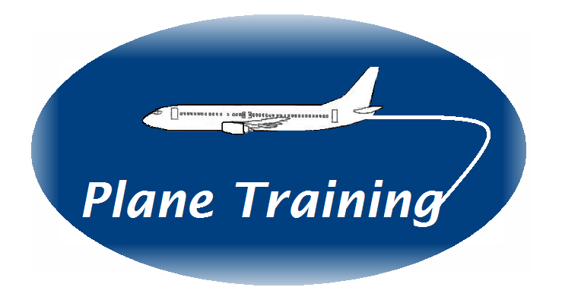COURSE PROGRAMME FOR CRM TRAINER COURSE

Please have a read through the recently updated CAP 737 ‘Flight Crew Human Factors Handbook’’

Course Aim
This course is designed for CRM trainers to develop their knowledge level and be able to deliver CRM training to both flight crew and cabin crew. The focus of the course is to expand delegate’s knowledge of modular CRM topics as well as practical application in the classroom through effective facilitation skills. There are a maximum of 6 delegates on the course.

The course strives to ensure that delegates enjoy the experience, find it useful to their own operation and leave with greater knowledge, confidence and a passion for the whole area of human behaviour both on and off an aircraft.

Regulatory Requirements
Delegates need to have previously completed an Instructional Techniques course before attending the CRM Trainer course.

Delegates need to have completed a flight crew initial CRM course (flight crew trainers) or an introductory CRM course (Annex V Part CC) for cabin crew CRM trainers

The course programme provides a minimum of 18 training hours (28 hours are programmed) (GM3 ORO.FC.115 & GM2 ORO.CC115(e) – Minimum Training Times)

CRM Modular Topics are described as specified in Table 1 of AMC1 ORO.FC.115 (flight crew) and Annex V Part CC and AMC1 ORO.CC.115 (cabin crew)

The Trainer delivering the course will have a minimum of 3 years’ experience. (AMC3 ORO.FC.115(c)(6) and AMC3 ORO.CC.115(c)(4)

Trainers should be assessed following this course by a Company nominated experienced trainer (GM7 ORO.FC.115 & GM5 ORO.CC.115)

Day One
45 Mins
Introduction and Welcome

1 Hour
Introduction to CRM Training (AMC3 ORO.FC.115(c)(2) & AMC3 ORO.CC.115(c)(2)
Behaviour and its effect on individuals and crew performance

2 Hours
Human Performance and Limitations – Basic Concepts and Review
Information Processing

45 Mins
2-Minute Practise Session

1 Hour
Questioning Techniques (focus on open and probing questions)

1 Hour 30 Mins
Training Planning and Preparation (GM4 FC115 & GM3 ORO.CC115)
Preparation for Practise Session
Day Two
30 Mins
Review of Day One

I Hour 15 Mins
Legislative requirements, different types and characteristics of CRM courses and CRM training applicable to type and operation (AMC3 ORO.FC.115(c)(iii) & AMC3 ORO.CC.115(c)(2)(iii)

30 Mins per delegate
Practise Sessions and Feedback AMC3 ORO.FC.115(c)(1) & AMC3 ORO.CC.115(c)(1)
Each delegate to deliver a session on a different topic of CRM. Course Trainer to then develop background knowledge of each topic

1 Hour 30 Mins
Facilitation Techniques and practise

1 Hour 15 Mins
CRM Topic – Startle and Resilience Development (GM5 FC.115 & GM4 ORO.CC.115

Day Three
30 Mins
Review of Day Two

1 Hour 15 Mins
Competencies, Behavioural Markers and application of CRM to line operations
(AMC3 ORO.FC.115(c)(1) & AMC3 ORO.CC.115(c)(1)

1 Hour
Operator’s Management System and Fatigue Risk Management (AMC3 ORO.FC.115(2)(ii) & AMC3 ORO.CC.115(2)(ii)

1 Hour 15 Mins
CRM Topic (as required and delivered by Course Trainer)

2 Hours
Using Practical Exercises and Case Studies for CRM training
Debriefing skills

1 Hour
Preparation for Practise Session

Day Four
30 Mins
Review of Day Three

45 Mins per delegate
Practise Sessions and Feedback AMC3 ORO.FC.115(c)(1) & AMC3 ORO.CC.115(c)(1)
Each delegate to deliver a facilitative session on a different topic of CRM using an exercise, case study or in-house example. Assessment as per GM7 FC.115 and GM5 ORO.CC.115 to be used for evaluating the session

1 Hour 15 Mins
Group Management and Difficult Behaviours (AMC3 ORO.115(b)(iv)(v) and AMC3 ORO.CC.115(b)(v)(vi)

1 Hour
Review of Design, Implementation and Evaluation of CRM training (GM3 ORO.FC.115 and GM3 ORO.CC.115
Additional Topic as required, Action Plans, Review and Close

Objectives:

By the end of this course delegates will be able to:

- Know the background and purpose of CRM Training
- Describe elements of Human Performance and Limitations/Human Factors and how this links into CRM training
- Learn and use a Human Factors Model
- Have a greater knowledge of CRM modular topics including startle effect and resilience
- Apply the legislative requirements to different types of CRM training programmes
- Plan, deliver and evaluate effective training sessions
- Use effective questioning techniques.
- Develop effective listening skills.
- Employ an appropriate facilitative training style
- Use a Behavioural Marker system
- Use and develop case studies for effective learning
- Identify and apply strategies to deal with different and difficult behaviours
- Describe how an effective SMS and FRMS is a driver for enhanced HF training
- Describe delegate’s own organisation and their specific operational challenges
- Know how to manage difficult and challenging behaviours
- Review personal strengths and weaknesses.

