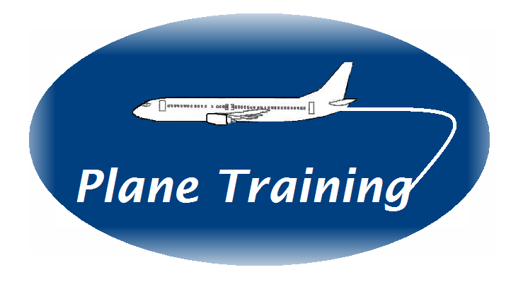COURSE PROGRAMME FOR CRM TRAINER REFERSHER COURSE

Please have a read through the recently updated CAP 737 ‘Flight Crew Human Factors Handbook’’ and Standards Doc 29 Version7.

Course Aim
This course is designed for experienced flight crew and cabin crew CRM trainers wishing to further develop and enhance their knowledge and skills for effective classroom training. There are a maximum of 6 delegates on the course.

The course strives to ensure that delegates enjoy the experience, find it beneficial to their own operation and leave with greater knowledge, skills and continued passion for human behaviour both on and off an aircraft.

Regulatory Requirements
The course programme provides a minimum of 6 training hours (GM3 ORO.FC.115 & GM2 ORO.CC115(e) – Minimum Training Times)

CRM Modular Topics are described as specified in Table 1 of AMC1 ORO.FC.115 (flight crew) and Annex V Part CC and AMC1 ORO.CC.115 (cabin crew)

The Trainer delivering the refresher course will have a minimum of 3 years’ experience. (AMC3 ORO.FC.115(c)(6) and AMC3 ORO.CC.115(c)(4)

Trainers should be assessed following this course by a Company nominated experienced trainer (GM7 ORO.FC.115 & GM5 ORO.CC.115)

Course Schedule
Timings are approximate according to number of delegates and their training needs.

45 Mins
Introduction and Welcome
Personal Key Objectives and Trainers Key Objectives

30 Mins
EASA legislative Brief and Update

1 Hour 30 Mins
CRM Top Topic – Startle Effect and Resilience Management/TEM

45 Minutes
Use of Behavioural Markers for classroom CRM training and link to simulator and line training.

45 Minutes
Classroom CRM training today – current observations and areas where training can improve

2 Hours
Practise Session - each delegate to deliver a session that they feel they have difficulty with. Feedback from course trainer

45 Minutes
Delegates area of choice – previously agreed area of delegates choice

30 Mins
Course review and reflection

Course Objectives:

By the end of this course delegates will be able to:

- Describe your personal key objectives to improve and develop performance
- Have a deeper knowledge of CRM modular topics including startle effect, resilience and TEM
- Apply the recent legislative requirements to different types of CRM training programmes
- Know and discuss the current observations during classroom CRM training from experienced CRM trainers and examiners
- Enhance the content and delivery of a training session from your current training programme
- Review effective use of a Behavioural Marker system
- Review personal strengths and weaknesses

Note: Practise session – please choose a training session that you feel needs improvement, adding to or would benefit from input and suggestions. We will ask you to deliver the intro to the session together with the objectives. Then move on to the area of the session that does not run as smoothly as you would wish it to – we will then help with some top tips for your consideration!

